ChargePoint

# Who is ChargePoint?

# How strong is the company?

Revenue & Profit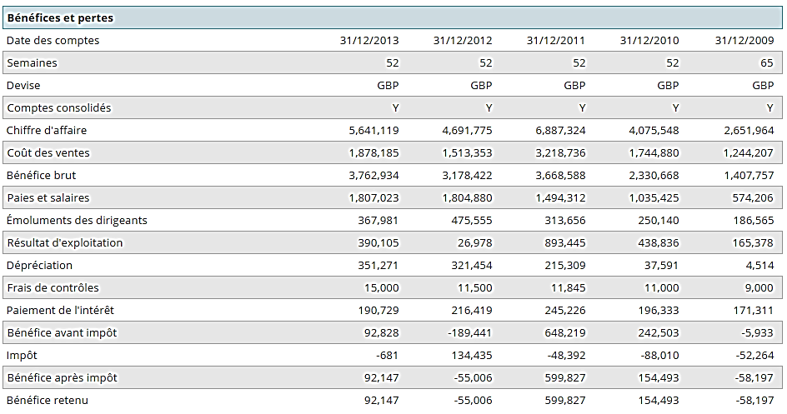

**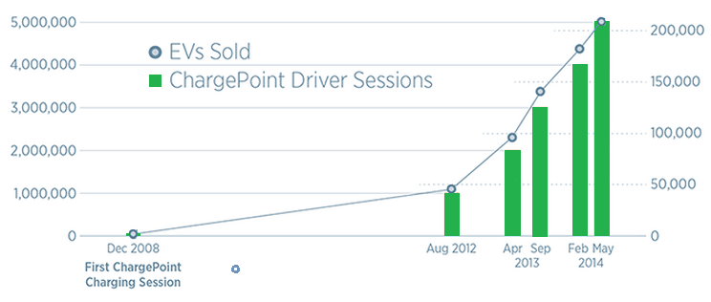**

## Market share

ChargePoint is the largest and most open electric vehicle (EV) charging network in the world, with more than 19,000 charging locations and a 70%+ market share. Ranked #1 by leading independent research firm, Navigant Research, ChargePoint makes advanced hardware and best-in-class cloud based software.

## R&D spending

[ChargePoint launched a $100 million lease financing fund](http://www.sacbee.com/2013/10/16/5826066/chargepoint-and-key-equipment.html) with partner Key Equipment Finance that's meant to jump-start the spread of public charging infrastructure.

## Patents

* [System and method for managing electric vehicles](http://patents.justia.com/patent/8935112) (**Patent number:**8935112)
* [Detecting and responding to unexpected electric vehicle charging disconnections](http://patents.justia.com/patent/8680813) **(Patent number:**8680813)
* [Street light mounted network-controlled charge transfer device for electric vehicles](http://patents.justia.com/patent/8866436) **(Patent number:**8866436)
* [Electrical circuit sharing for electric vehicle charging stations](http://patents.justia.com/patent/8502500) **(Patent number:**8502500)
* [Network-controlled charging system for electric vehicles](http://patents.justia.com/patent/8450967) **(Patent number:**8450967)
* [Breakaway mechanism for charging cables of electric vehicle charging stations](http://patents.justia.com/patent/8410369) **(Patent number:**8410369)
* [Self powered electric vehicle charging connector locking system](http://patents.justia.com/patent/8460028) **(Patent number:**8460028)
* [Network-controlled charging system for electric vehicles](http://patents.justia.com/patent/8432131) (P**atent number:**8432131)
* [Authorization in a networked electric vehicle charging system](http://patents.justia.com/patent/8354913) **(Patent number:**8354913)
* [Dual electric vehicle charging station](http://patents.justia.com/patent/D710799) **(Patent number:**D710799)
* [Dual electric vehicle charging station](http://patents.justia.com/patent/D711313) **(Patent number:**D711313)
* [Dual electric vehicle charging station](http://patents.justia.com/patent/D711315) **(Patent number:**D711315)

ChargePoint is obviously leader in innovation. The number of patents over the past few years shows us there strategy is to create, in order to maintain the competitive advantage they have over the concurrence. Indeed, doing so, they remain the leading company in the US on charging stations, and are the one companie people turn to, as long as they keep the lead in innovation and creativity.

# How do they attract customers

## Price

ChargePoint CT4000 Charging Station – Level 2 240/208V/J1772 with Provisioning: $3,990.00–$7,210.00

Price per hour depends on the reseller, but most ChargePoint stations are free to use, with the ChargePoint card.

## Services

ChargePoint’s real-time network information (including the availability of charging locations throughout the nation) is available through the **ChargePoint mobile app**, online and via the navigation systems in top-selling EVs including the new BMW i3 and the Nissan LEAF.

All ChargePoint stations are covered by **ChargePoint Assure**, a one year parts and on-site labor warranty. If a charging station fails due to a manufacturing defect, the ChargePoint Support team will visit your site to repair the defect or replace the station.

To ensure stations are installed with the highest quality standards and at the lowest possible cost, ChargePoint has partnered with select national operations & maintenance partners (**O&M partners**).

**ChargePoint Cloud Services** provide the ability to control every aspect of policy, pricing, management, and reporting on a daily basis.

**ChargePoint Station Management** is ChargePoint’s premium Managed Services product where the expert support team manages stations for the customer. The support team will deal with any issues, make any requested policy and pricing changes and provide regular reporting so the customer can measure the impact of the stations on his business.

## Product (technology, location)

* ChargePoint Home
* CT4000 family of charging stations (level 2 – 25 RPH)
* ChargePoint Express 200 ((Fast Charging – 200 RPH)

Why drivers choose ChargePoint?

* **More charging locations** than anyone else: more than 20,000 charging spots and counting.
* **Easy to find** places to charge. With the mobile app and real-time data, it’s easy to find available stations and start charging.

**Simplify**. All car models work on ChargePoint charging stations (CHAdeMO-compatible cars include the Nissan LEAF, Tesla Model S (with adapter) and Kia Soul EV; SAE Combo-compatible cars include the BMW i3, Chevy Spark EV and Volkswagen e-Golf) and, through their ChargePoint account, drivers can keep track of their favorite charging spots and personal data, like how much money they are saving and their shrinking carbon footprint.

* **ChargePoint Home**. It’s the world’s most advanced EV charging station for the home, and it’s also connected with all your public charging.
* With ChargePoint Express locations, DC fast charging on our network, **long road trips** are easy

Every 7 seconds, a driver connects to a ChargePoint station and by initiating over 6.8 million charging sessions, ChargePoint drivers have saved over 6.2 million gallons of gasoline and driven 144 million gas free miles.

# Where are they doing business?

ChargePoint targets companies and individuals to sell its charging stations. Manufacturing and R&D are actually let to “suppliers”.

They are mainly located in the US, where they have most of the market shares on charging stations. They haven’t been over different markets yet, despite a beginning in Asia. Nothing in Europe and Oceania.

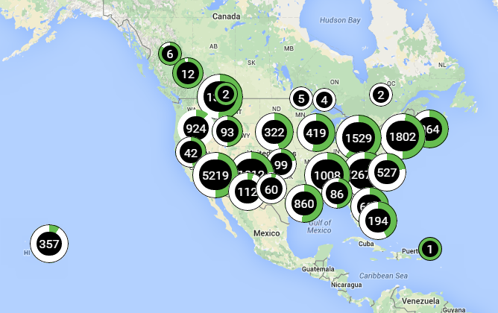

## C:\Users\Jacquelin\Desktop\Tsinghua\Spring Semester\GMS\GMS_group5\Case studies\Companies\ChargePoint\Locations2.PNG

# With whom do they do business?

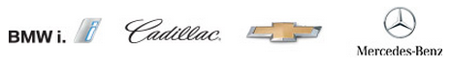



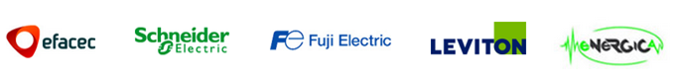

**EV:** BMW I, Cadillac, Chevrolet, Fiat, KIA, Mercedes, Nissan, Smart, Volkswagen

**Commercial:** Efacec, Schneider Electric, Fuji Electric, Leviton, Energica

# What is their competitive advantage?

Why businesses choose ChargePoint?

Perhaps the most important reason why businesses choose ChargePoint is because it’s the network drivers prefer. Plus:

* EV charging is good for business. Offering EV charging is a great way to attract and retain shoppers, visitors, tenants, and employees. It can also help you stand out from the competition, meet your sustainability goals and earn incremental revenue.
* Be in control. All ChargePoint’s stations are independently owned. Plus, ChargePoint’s cloudbased solutions give businesses the flexibility to set their own prices, and seamlessly automate payment processing, reporting, and analytics.
* Easy to work with. ChargePoint provides world-class service products and support to keep your stations online, 24/7 driver support, and intelligent energy management to help you keep electricity costs down.
* Flexibility. ChargePoint builds advanced charging stations, and its open network works with charging stations built by any manufacturer.
* ChargePoint puts businesses on the map. When businesses buy ChargePoint stations and become part of our network, they are immediately visible to all our drivers.
* ChargePoint gets the word out. Because we have the largest community of EV drivers, ChargePoint can be an effective way to promote your business and products

In conclusion, ChargePoint is mostly taking advantage of the growing market and the fact that it owns the biggest part of the US market. This fact makes them extremely visible, and leads customer to go to them whenever a charging station is needed.

They try to create products that are very compatible to most of the standards around the word. For example, the leading standards for fast-charging stations are developed by CHAdeMO, a Japanese association of EV-related companies (see CHAdeMO Case Study). Every station in Japan and most of the fast-charging stations around the world are using these standards, and ChargePoint is taking this fact into account, usig CHAdeMO’s standards in the making of its fast-charging stations.

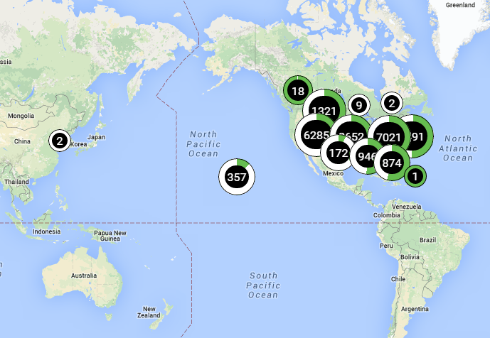

Figure 1: ChargePoint charging stations in the world

<https://na.chargepoint.com/charge_point>

ChargePoint

History

ChargePoint (formerly Coulomb Technologies (CT)) is an electric vehicle infrastructure company, based in Campbell, California. Coulomb Technologies was founded in **2007** by Richard Lowenthal (CEO) and Praveen Mandal. CT’s aim was to offer ChargePoint Networked Charging Stations that includes *Public charging stations*; *A consumer subscription plan*; *Utility grid management technology* for electric utility companies (to smooth electrical demands on the grid)

In **January 2009**, the company's first charging stations were deployed in downtown San Jose that drivers can access through a prepaid plan.

Expansion

ChargePoint is currently the largest and most open electric vehicle (EV) charging network in the world, with more than 19,000 charging locations and a 70%+ market share. Since its first charging station installation, Coulomb charging stations have been in more than 27 US states, Canada and Europe.

****

Figure 2:Every 7 seconds, a driver connects to a ChargePoint station and by initiating over 6.8 million charging sessions, ChargePoint drivers have saved over 6.2 million gallons of gasoline and driven 144 million gas free miles.

Ranked #1 by leading independent research firm (Navigant Research), ChargePoint makes advanced hardware and best-in-class cloud based software. The company also [launched a $100 million lease financing fund](http://www.sacbee.com/2013/10/16/5826066/chargepoint-and-key-equipment.html) with partner Key Equipment Finance that's meant to jump-start the spread of public charging infrastructure.

In America, the ChargePoint America project sees 1,800 240-volt charge stations being built. Sponsored by Coulomb Technologies, the $37 million project is backed by a $15 million DOE grant, provided through the Recovery Act. ChargePoint America has provided 4,600 networked charging stations to homes and public locations (October 2011), adding to the existing ChargePoint Network. The ChargePoint America project will collect data on vehicle use and charging patterns, which will be analyzed by DOE's Idaho National Laboratory.

It has announced its expansion into Europe, the Middle East and Africa with the opening of Coulomb’s European headquarters represented by 365 Energy Group, a venture of Estag Capital AG, in Berlin, Germany. Coulomb Technologies' ChargePoint public charging stations are also already in Australia.

ChargePoint Today

Three main products:

* ChargePoint Home
* CT4000 family of charging stations (level 2 – 25 RPH)
* ChargePoint Express 200 (Fast Charging – 200 RPH)

ChargePoint targets companies and individuals to sell its charging stations. Manufacturing and R&D are actually let to “suppliers”. This strategy lead them to partner up with many companies, including car industries, electricity suppliers, …





Figure 3:EV: BMW I, Cadillac, Chevrolet, Fiat, KIA, Mercedes, Nissan, Smart, Volkswagen



Figure 4: Commercial: Efacec, Schneider Electric, Fuji Electric, Leviton, Energica

Another main aspect of their strategy is the focus on customer services. The **ChargePoint mobile app** gives real-time network information (including the availability of charging locations throughout the nation). **ChargePoint Assure** covers all ChargePoint stations (one year parts and on-site labor warranty). All maintenance operations are done with the **ChargePoint Station Management,** by a partner company, often selected among select national operations & maintenance firms. Finally, every aspect of policy, pricing, management, and reporting on a daily basis can be controlled via the **ChargePoint Cloud Services**. For example, through their ChargePoint account, drivers can keep track of their favorite charging spots and personal data, like how much money they are saving and their shrinking carbon footprint.

But ChargePoint has other advantages that lead customer to choose their services: **More charging locations** than anyone else (20,000+ charging spots and counting). **Easy to find** charging stations (with the mobile app and real-time data, it’s easy to find available stations and start charging). **All car models** work on ChargePoint charging stations (e.g. CHAdeMO-compatible cars, SAE Combo-compatible cars). Plus, with **ChargePoint Express locations**, DC fast charging on our network, **long road trips** are easy. Last, but not least, **ChargePoint Home**. It’s the world’s most advanced EV charging station for the home, and it’s also connected with all your public charging.

With a **dozen patents** since 2013, ChargePoint is obviously **leader in innovation**. Its strategy is to create, in order to **maintain the competitive advantage** they have over the competition. Indeed, doing so, they remain the leading company in the US on charging stations, and are the one company people turn to, as long as they **keep the lead** in **innovation** and **creativity**.

Conclusion

ChargePoint is currently the **obvious leader** of the American market for charging stations. They arrived **early** **on** **the** **market**, and have controlled it since by keeping on creating, innovating, and proposing new services. Today, they are the one company people turn to when it comes to charging stations.

In order to create the right products, they have choose to team up with many very successful companies, that ally quality and innovation (BMW, Mercedes, Volkswagen, Chevy…) and are the most successful companies in their domain, worldwide (Schneider Electric, Efacec, …). They thus use not only their partners’ skills in innovation and manufacturing, but also their brand image, creating for themselves a name that combines all those qualities.

Another winning strategy was the use of **many standards**. ChargePoint stations are compatible with the CHAdeMo fast-charging standard, but also the UE-US Combo standard, and also include level 1 & 2 charging. Right now, they keep their options open, by making any EV user able to use one of their charging stations, and try hard not to exclude any user.

Today, they are starting a strategy of expansion, targeting the EU and Australia. Far away from the issues of the battle to come between CHAdeMO (Asia) and Combo (EU+US) standards (see page ??), since they create combined products, they will try to impose a model that has been successful in the US. Plus, apart from Estonia (that has most of the territory covered with charging stations – see page ??), the majority of European countries have big investments to make, in order to become EV-compatible. Which, if they want to eventually be sustainable, they will have to do.

# For Hester

This case study can be used in pages 9-10 of the layout. Or some others. But the images of locations of charging stations in the word are nice, and can be used as in page 9, I think.

In the conclusion, I use references to other case studies, putting (see page ??). This will have to be edited at the very end, replacing ?? with the actual pages.

Green text

Every 7 seconds, a driver connects to a ChargePoint station and by initiating over 6.8 million charging sessions, ChargePoint drivers have saved over 6.2 million gallons of gasoline and driven 144 million gas free miles.

ChargePoint is mostly taking advantage of the growing market and the fact that it owns the biggest part of the US market. It makes them extremely visible, and leads customer to go to them whenever a charging station is needed (p.7)

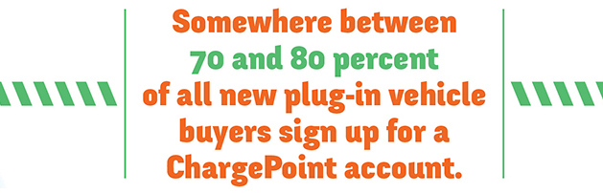

Big fat grey text

70%+ market share (p.2)

Ranked #1 by Navigant Research (p.2)

ChargePoint supports All car models (p.5)

# References:

<http://fr.companycheck.co.uk/company/06712991/CHARGEPOINT-TECHNOLOGY-HOLDINGS-LIMITED/financial-accounts>

<http://patents.justia.com/assignee/chargepoint-inc>

<http://www.chargepoint.com/>

<https://na.chargepoint.com/charge_point>